[1]

SOUTH COLOMBIAN UNIVERSITY

ELECTRONIC ENGINEERING

ELECTRONIC ANALOGUE

PRE-REPORT No. 6

TRANSISTORS

Dumar Alexander Delgado Martinez, 20221206321  
Juan Esteban Diaz Delgado, 20212201615

Joan Alejandro Sánchez Rojas, 20221206851

***Summary—*** ***For this laboratory practice, we will work with bipolar transistors, where it is understood that the current flow is established through the different regions of the transistor, this practice is done in order to manage an adequate and essential polarization to ensure that the transistor works efficiently and reliably.***

***Keywords—*** ***Polarization, transistors.***

I. OBJECTIVES

General objetives.

⮚ Acquire practical knowledge and experimental skills that allow them to understand the behavior of bipolar transistors in a circuit and apply this knowledge in future projects and electronic designs.

# Specific objectives

# ⮚ Understand the basic theoretical concepts of the polarization of bipolar transistors and its relationship with the behavior of the transistor.

# ⮚ Become familiar with the use of electronic measurement instruments, such as multimeters, oscilloscopes, and signal generators.

# ⮚ Design bipolar transistor bias circuits in different configurations, such as common-emitter bias and common-base bias.

II. THEORETICAL FRAMEWORK

**A. What are BJT transistors?**

Bipolar junction transistors (BJTs) are semiconductor devices used to amplify or switch electrical signals. A BJT consists of three regions of semiconductor material: the base region, the collector region, and the emitter region.

***Image 1. Bipolar junction transistor.***

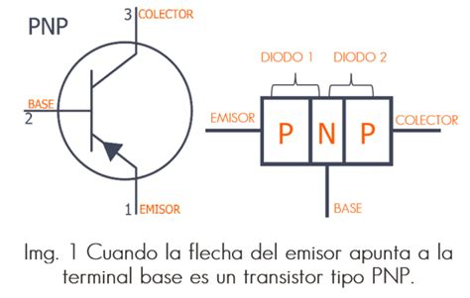

[1]

The base region is the narrowest region and is located between the collector and emitter regions. The collector region is the largest region and is located at the opposite end of the emitter region. The emitter region is located at the end of the transistor that is closest to the base region.

**B. How are BJT transistors made?**

BJTs are constructed in two main types: NPN transistors and PNP transistors. In an NPN transistor, the base region is of P-type and the collector and emitter regions are of N-type. In a PNP transistor, the collector and emitter regions are of P-type and the base region is of N-type.

***Image 2. NPN and PNP transistor.***

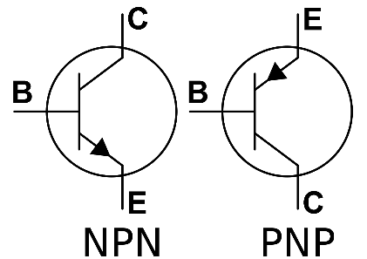

[2]

**C. How is the operation of a BJT transistor?**

The operation of a BJT is based on the base current, which is the current that flows through the base region. When a current is applied to the transistor's base, a current flow is produced between the collector and emitter regions. The transistor is commonly used as a signal amplifier and a switching device.

***Image 3. Operation of the transistor.***

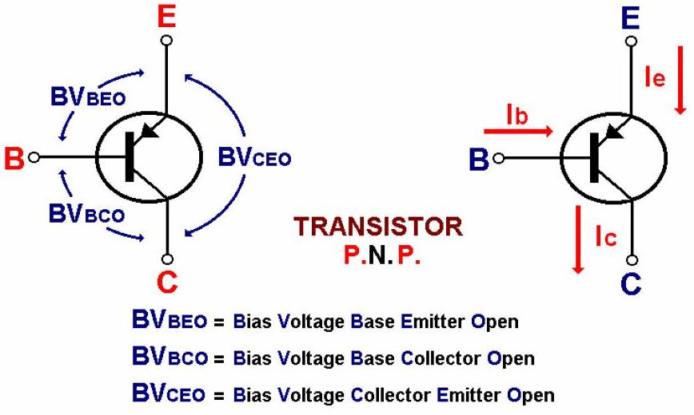

[3]

In an amplifier, the base current is used to control the current flowing between the collector and emitter regions, allowing for amplification of the input signal. In a switching circuit, the base current is used to turn the flow of current between the collector and emitter regions on or off, allowing for electronic devices to be turned on or off.

In summary, BJTs are semiconductor devices used to amplify or switch electrical signals. They consist of three regions of semiconductor material: the base region, the collector region, and the emitter region. BJTs are constructed in two main types: NPN and PNP transistors. They are commonly used in amplification and switching applications and are fundamental to modern electronics.

**D. Where are transistors used?**

BJTs are widely used in modern electronics because of their ability to amplify signals and act as switches controlled by electrical signals. Some components and devices that use BJTs include audio and video amplifiers, radios, televisions, power supplies, motors, fluorescent lamps, speed control systems, electronic switching devices, and signal processing systems.

BJTs are also used in a variety of configurations, including class A, class B, class AB, and class C amplifiers. Each of these configurations has its own characteristics and specific applications.

In addition, BJTs are also used in integrated circuits and in high-frequency devices such as oscillators and radiofrequency amplifiers. They are also used in feedback circuits and in voltage stabilization circuits.

Regarding the construction of BJTs, they are manufactured using diffusion and deposition techniques of semiconductor materials onto a silicon substrate. The materials used include silicon, germanium, and other semiconductor materials. The manufacturing process may include doping layers to adjust the electrical properties of the device.

In summary, BJTs are fundamental components in modern electronics, used in a wide variety of applications ranging from audio and video amplifiers to speed control systems and electronic switching devices. They are constructed using deposition and diffusion techniques of semiconductor materials and are used in a variety of high-frequency devices and configurations.

# III. MATERIAL ELEMENTS AND EQUIPMENT

* 1 endurance of 2,7 kΩ
* 1 resistance of 1 MΩ
* 1 resistance of 33 kΩ
* 1 resistance of 1,8 kΩ
* 1 resistance of 6,8 kΩ
* 1 resistance of 680 Ω
* 1 transistor 2N3904
* 1 transistor 2N2222

IV. PROCEDURE

In this laboratory, a series of circuits will be presented to demonstrate the usefulness of transistors, and the calculated results will be analyzed alongside the measured ones. To begin, a 20-volt source will be used to power a circuit that will be controlled and regulated by resistors to avoid exceeding the limits set by the manufacturer. The central current will be injected through the collector, and this energy will also flow to the base, but with a higher resistance to avoid exceeding those limits.

**Table 1.** Measurements of the 2N3904 transistor

In order to achieve a fixed polarization, the previous data was used to calculate the corresponding voltages, which were measured and compared with the values obtained through calculations.

**Table 2.** Results of the 2N3904 voltages.

Similarly, it was decided to change the transistor, using the same resistors to observe the differences between transistors.

**Table 3**. Results of the calculated and measured transistor 2N4401.

It is concluded that, even if there are minimal changes, the main objective of turning on the transistor without exceeding the established values is achieved, since it is capable of withstanding up to 20 volts.

**Table 5.** Results of both transistors.

The outputs are regulated and stable, although when measured and passed through the oscilloscope a little noise is observed, which may be due to connections or false contacts that are usually irrelevant to the final data.

**Part 2**

In the second part of the laboratory, the Zener regulator is addressed and a design that meets certain specifications was proposed, among which are:

* RL = 470Ω according to specifications.
* Vin = 120Vrms according to specifications.
* Vz = 9V according to specifications.
* Vrip = 3Vpp according to specifications.
* f = 60Hz according to specifications.

The input peak signal is calculated.

Vp = Vin x √2 = 120Vrms x √2 = 169.7

Similarly, the minimum current passing through the diode.

Izener-min = (Vp - Vz) / RL = (169.7Vp - 9V) / 470Ω = 357.7µA

On the other hand, the maximum current of the diode is calculated

Izener-max = Pzener / Vzener = (Vrip/2)^2 / Vz = (1.5V)^2 / 9V = 0.25W / 9V = 27.8mA

The resistance through which the maximum current passes without overheating is calculated.

R = (Vin - Vzener) / Izener-max = (120Vrms x √2 - 9V) / 27.8mA = 3.8kΩ

And the last step was to calculate the capacitance of the laugh.

Cmin = Izmin / (2πfVrip) = 357.7µA / (2π x 60Hz x 1.5V) = 125.7µF

V. ANALYSIS OF RESULTS

Tables 1 and 3 indicate that the data for transistor 2N3904 and 2N4401 are very similar, with a βDC measurement of 372, suggesting a high gain. However, it should be noted that the gain of a transistor can vary depending on the circuit configuration and operating conditions. The measurements of RB and RC allow us to know the base and collector resistance of the transistor, necessary to calculate the base and collector current. The measurement of VBE and VRC is necessary to calculate these currents using the corresponding equations. The measured value of IC is 7.4 mA, indicating that the transistor is in its active region. Tables 2 and 4 show the measured and calculated values of different fixed bias parameters of a bipolar transistor. The calculated base current (IB) is 20 μA and the calculated collector current (IC) is 3.3 mA. The measured values are similar to the calculated ones, although there are some small differences due to factors such as the internal resistance of the measuring equipment and the variability in the transistor characteristics. Table 5 shows the values of VCE, IB, IC, and β for two different bipolar transistors in a voltage division bias circuit. Both transistors have similar values of VCE, IB, IC, and β. In Table 6, a very small percentage change in the measured quantities is observed, suggesting that the fixed bias circuit is effective in establishing a constant bias current and obtaining stable transistor operation.

VI. CONCLUSIONS

* In this practice, practical and theoretical knowledge of how to polarize and use the bjt transistor depending on its reference was obtained, in the same mood it is observed that there are some differences in this case due to the specifications provided by the manufacturer.
* The design proposal of a voltage regulator that uses a Zener diode and a resistor in series is a practical and effective solution to achieve a stable and safe 9V power supply. This solution uses standard components and ensures safe and stable operation of the Zener diode by limiting the maximum current flowing through it.
* In the laboratory, bipolar transistors with the references 2N3904 and 2N4401 are used, which have similar direct current gain values. These transistors operate in their active region, where the current flowing through the collector is controlled by the current flowing through the base.

# V. REFERENCES

[1] Taken from the

<https://uelectronics.com/transistores-bjt/>

[2] Taken from the web

<https://shoptransmitter.com/blog/what-is-the-difference-between-pnp-and-npn/>

[3] Taken from the web

http://electronicapractica2012.blogspot.com/2012/06/el-transistor-bipolar-bjt.html

[-] Taken from the web

<https://en.wikipedia.org/wiki/Bipolar_junction_transistor>

<https://www.electronics-tutorials.ws/transistor/tran_1.html>

https://learnabout-electronics.org/Semiconductors/bjt_01.php

1.